Coláiste Feirste
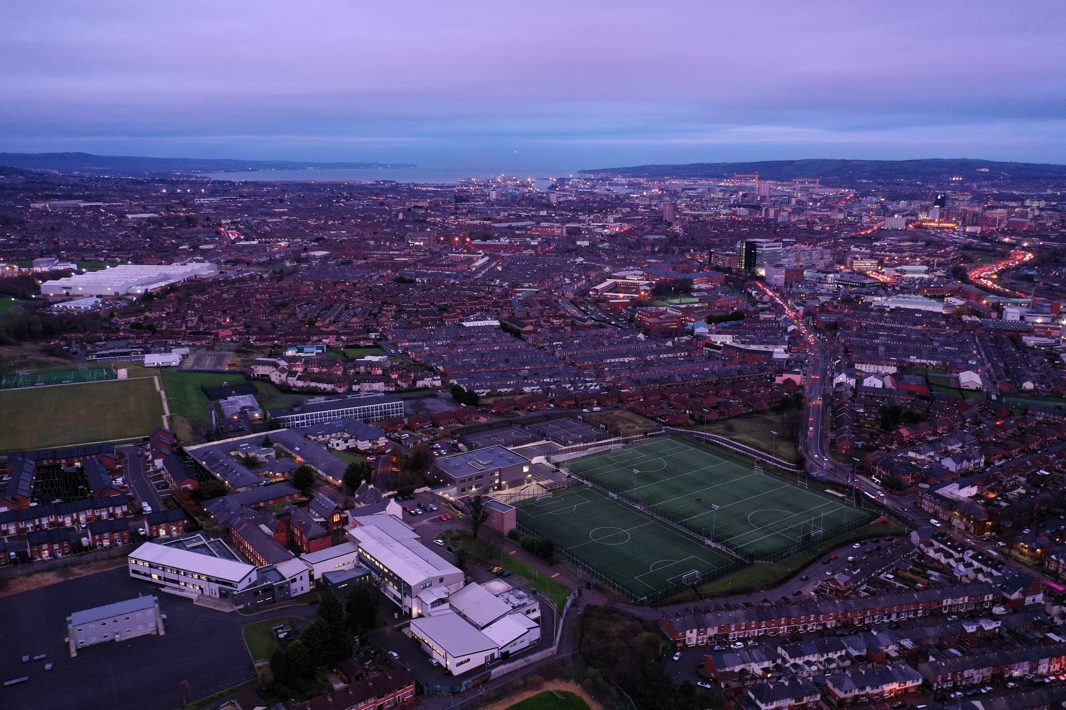
Restart

Measures and Procedures for the mitigation of Covid-19

Coláiste Feirste has conducted a risk assessment, as directed by the Department of Education, to ensure that our school is safe for the return of our school community. We continue to adapt our school to incorporate public health guidance from the Department of Education (DE) and we endeavour to make our school as safe as we can.

It is essential that all staff and pupils follow this guidance in order to protect themselves and limit the spread of the virus to educational settings and the wider population.

Contents:

- Daily Routines
- Arrival to and from school
- Social Distancing
- Stationary and equipment
- Curriculum and learning: Our Classroom
- Hygiene
- Cleaning
- Respiratory Hygiene and Face Coverings
- PPE
- School Uniform
- Lunch and Break
- Well-being
- Pupils and staff who become sick
- Communication

1. A Summary of Daily Routines

- Pupils and staff adhere to social distancing guidelines including entry and exciting school grounds, in the classroom, on corridors, at lunch and break time and accessing toilets.
- Pick up and drop off in the morning and afternoon is restricted to An Spórtann. These gates will open between 8.00 – 9.30am and 2.30pm onwards.
- Signage will be in place throughout the school and on entry to the school.
- The allocation of zones (KS4 and KS5) and bubbles (KS3) will allow for the restriction of movement throughout the school. Key Stage Three pupils will remain in their bubble throughout the day, which includes practical classes.
- Specific entry zones and toilet blocks will be allocated to each key stage.
- Despite procedures put in place to reduce traffic within the building, pupils must adhere to the corridor systems put in place and more importantly, pupils must stay left whilst walking through the school. In most cases, our school building does not allow for one way systems and therefore we ask all pupils to be mindful of this rule at all times.
- In order to increase separation and decrease interaction between pupils, the school doors will open no earlier than 8.45am. The rationale behind this is to ensure pupils will be supervised as they arrive in their specific zones.
- On entry to the school building, all pupils will go straight to their allocated room and seat.
- A track and trace monitoring system for bathroom breaks will be put in place.
- Visitors to the school - In order to ensure that the school environment remains safe and healthy, visitors to the school will be by appointment only. Visitors will be required to sign-in according to school policy, however additional information for the ease of contact tracing will be required.
- Coláiste Feirste has a ‘clean desk’ policy. De-cluttering of office space and classrooms will ensure that surface hygiene is easily maintained.

2.Arrival to and from school

- For pupils with specific needs, arrangements can be made through Mary Uí Dhaimhín (SENCO).
- Pupils may only gain access to the school building after 8.45am and must enter via their designated areas.

 | KS3  (Code: Glas) | KS4  (Buí) | KS5  (Gorm)
Designated Doors | Bloc D  (Urlár na Gaeilge) | Bloc C (Technology) | General office (main school entrance)

- Non-Teaching Staff and SLT will be on morning duty and form tutors will arrive at 8.55am.
- Awareness will be raised regarding safe traveling on public buses, however pupils will be responsible for adhering to Translink and other transport policies independently. We value and encourage parental/guardian support on this matter. Face coverings are required on public transport for pupils over 13. https://www.eani.org.uk/education-restart

3.Social distancing

- As far as is practicable social distancing will be maintained between adults and children.
- We will continue to support young people to observe social distancing.
- Staff members and visitors are required to adhere to the current PHA guidelines on social distancing.
- Pupils who wilfully refuse to adhere to arrangements of social distancing will be dealt with in accordance with the school’s behaviour for learning policy.
- Teachers will move to classes instead of pupils moving. Breaks and lunch will also be taken as a bubble. KS3 will be located in Bloc D. Each form class will be allocated a room.
- KS5 pupils will be allocated rooms in Bloc B (zone).
- KS4 pupils will be allocated rooms in Bloc C (zone).
- Due to the nature of GCSE, BTEC and A Level classes, these pupils will move between floors for classes. Students will be advised and expected to maintain social distancing.
- Classroom assistants will be viewed as part of the protective bubble in which their assigned pupil is. Social distancing may be relaxed in this instance however, PPE is available.
- See Lunch and Break section for more information.

4.Stationery and equipment

- Pupils must come to school equipped with their own personal stationery, daily.
Basic stationary required:
- Pens (black/blue and red/green)
- Ruler
- Pencil
- Rubber
- Sharpener
- Calculator
- Wipeable pencil case
- Stationery must not be shared between pupils.
- Pupils are permitted to bring school bags to school and we recommend bags are washed on a regular basis.
- Pupils will receive their books in school however workbooks will be kept in designated classes to lessen the risk of transmission.
*Please note that recommendations for books and equipment may change, or vary. We will communicate with pupils and parents regarding any updated information.

5.Curriculum and learning: Our classroom

- All pupils will go through a learning induction (catered specifically for Irish Medium Pupils) as well as a pastoral induction to address the time lost during lockdown.
- Homework at KS3 is suspended for the beginning of September. Teachers and pupils will engage via Google Classroom in preparation for learning.
- Pupils will continue to use Google Classroom for learning and all pupils must be prepared for learning, each day. Pupils and parents will receive further guidance on curricular and learning matters at the start of term.
- Coláiste Feirtse aims to communicate more effectively with parents on the learning journey and schemes of work will be available via the school website under ‘curriculum’. Parents may also link with Google Classroom. Parents are encouraged to communicate with form tutors via email with any initial concerns.
- Despite reopening of bubbles and zones, Coláiste Feirtse will prepare for remote learning during this uncertain time through the blended learning approach.
- Curriculum leaders will audit ICT resources and Google Classroom accessibility at home through focus groups and questionnaires.
- Teaching styles, interactions and communication methods will adapt according to social distancing regulations, throughout the curriculum.
- New classroom layouts aim to ensure that pupils are not facing each other, as much as possible.
- Pupils will be given a designated seat in their class and will adhere to this plan to keep transmission rates low.
- As the 2m social distancing rule between members of staff and pupils must be strictly adhered to, the personal space of all staff members must be respected during classes.
- Despite face coverings not being mandatory during teaching, they may be used by any staff member or pupil in class. The wearing of face coverings is mandatory for all staff members when 2m cannot be sustained, in any context.
- Practical subjects at KS3 (Technology, ICT, HE, Music, Drama, Art, Science) will be based in the designated form classes and will be theory based. KS4 and KS5 will be prioritised for practicals due to pending examination pressures.
- Curriculum delivery will be reviewed regularly by Heads of Department and SLT.
- Physical Education plays an integral role in the health and wellbeing of pupils. Restrictions relating to changing rooms will require pupils to come to school in the school PE kit on the day they have PE. Facilitation of PE will vary depending on the weather as outside activities are only permitted. Theory will be taught in the form class when this is not possible.
The safety of our pupils and staff through our high quality pastoral and curricular standards is paramount and therefore the above changes to the learning environment are necessary.

6.Hygiene

- Pupils and staff will be required to clean their hands on arrival at school, before and after eating, changing rooms and after sneezing and coughing.
- Hand sanitizers are placed throughout the school building to ensure there is sufficient access to hand washing, regularly. Additionally, soaps and towels are placed in classrooms where running water is available. Classrooms without running water will be equipped with hand sanitizer.
- Classrooms will be ventilated throughout the day.
- Waste will be collected throughout the school day.
- Signage and pastoral sessions will be used to raise awareness on the importance of hygiene matters.
- The sharing of drinking bottles and other equipment between pupils will be prohibited.

7.Cleaning

- Cleaning schedules will remain the same with specific focus on high risk areas (practical suites, hard surfaces, door handles, electronic devices, telephones and photocopiers).
- Hygiene equipment and resources will be replenished regularly.
- Each classroom will have a cleaning/sanitation kit and a supply of tissues. Teachers and pupils will maintain classroom spot cleaning.
- The daily cleaning team will focus on high touch areas throughout the day.
- Cleaning records will be maintained.
- Staff and students should inform the general office of any cleaning issues as soon as they arise.

8.Respiratory Hygiene and Face Coverings

- Despite the resources in school, staff and pupils are encouraged to bring their own tissues.
- All will be encouraged to ‘catch it, bin it. kill it’.
- Masks may be worn in accordance to PHA guidance staff/pupils.
- It is strongly recommended that pupils wear face coverings in corridors and social areas inside the school. Staff will remind pupils of this regularly.
- Face coverings (masks) are compulsory for staff where the 2m cannot be sustained, in any context.
- Staff and visitors must wear a face covering in instances where meetings are held in rooms that are not easily ventilated.
- All visitors must wear face coverings.
- Disposable face masks will be available on the school grounds, however all staff (and pupils if they wish) are encouraged to bring their own.

Please contact the Head of Year with queries regarding any of the Covid-19 regulations.

9.PPE

- PPE will be provided by Coláiste Feirste for staff providing intimate care, first aid and other exceptional circumstances.
- PPE kits will be provided in each block within the school as a cautionary measure in the instance of a pupil/staff member developing Covid symptoms.
- PPE equipment provided for these instances include
- Protective gloves
- Fluid resistant surgical mask
- Disposable aprons
- Plastic visor
- Cafeteria staff are required to wear
- Protective gloves
- Plastic aprons
- Visor

10.School Uniform

While Coronavirus can land on fabrics and remain for some time, schools are not a high risk environment and while all young people should be encouraged to wear clean uniform or fresh clothes each day, this is not essential.
*Refer to the school uniform policy for further details

11.Lunch and Break

- There will be no morning or break food provided by the canteen.
- Staggered break times will reduce traffic within the school building.
- Sanitizing stations will be placed at the cashless catering systems and water vending machines.
- Pupils will be encouraged to stay safe and wash their hands whilst in the playground and canteen.
- Pupils will be separated according to year groups (in designated areas) for outdoor activities during lunch and breaks.
- Pupils eating packed lunches will not go to the canteen.

12.Well-being

- Coláiste Feirtse will provide PPE for learning support staff to allow for closer contact.
- Student well-being will be surveyed through our baseline tool (PASS) and focus groups.
- Parental communication is vital to move forward and the pastoral team (Form Tutor & Year Head) will make contact with updates.
- Classroom assistants and the SENCO will contact parents regarding vulnerable and/or SEN pupils.
- Through pastoral and learning inductions, Coláiste Feirste strives to welcome pupils into a positive and safe environment.
- Counselling services will continue online and pupils and parents can contact the Form Tutor to arrange sessions or internal support.
- Our Safeguarding Team will provide training to all staff and pupils on Child Protection (CP) issues. Emer Mic an Fhailli and Siobhán Nic Giolla Eain should be contacted with any CP concerns.
- The positive learning environment is dependent upon good attitudes towards learning and adhering to Coláiste Feirtse’s Behaviour for Learning Policy. We expect all our pupils to maintain the highest behaviour standards, especially during these challenging times.
- Marking and assessment feedback will prove difficult for teachers. Teachers may opt to use PPE, if comfortable in order to write feedback in books. Alternative ways to give feedback are encouraged (Google Classroom, model answers, verbal feedback, self-marking etc).

13.Pupils and staff who become sick

- At all times, pupils and staff should follow government guidelines.
https://www.publichealth.hscni.net/covid-19-coronavirus
- Staff and parents are encouraged to download the ‘StopCovid NI’ from the Google or Apple App store now to help stop the spread of coronavirus. At this time, the app is not available for anyone under 18.
.
- Pupils and staff who have Covid 19 symptoms, should never enter the school building.

The symptoms of Covid-19 are:

- a high temperature – this means you feel hot to touch on your chest or back (you do not need to measure your temperature)
- a new, continuous cough – this means coughing a lot for more than an hour, or 3 or more coughing episodes in 24 hours (if you usually have a cough, it may be worse than usual)
- a loss or change to your sense of smell or taste – this means you've noticed you cannot smell or taste anything, or things smell or taste different to normal

To protect others, do not go to places like a GP surgery, pharmacy or hospital if you have any of these symptoms. Get a test to check if you have coronavirus and stay at home until you get your result.
** Book a test at: www.nhs.uk/ask-for-a-coronovirus-test or telephone 119

- If a pupil becomes unwell with symptoms of coronavirus and needs direct care, the member of staff will wear PPE while tending to the pupil until their parent/guardian arrives to collect them.
- The general office will contact the family and record the incident.

**Coláiste Feirste has a strict mobile phone policy and pupils must not contact parents via their mobile phone. This can create panic and miscommunication between parents and the school. Pupils must communicate with teachers or their form tutor if they feel ill.

- The pupil will be kept in isolation in a well ventilated room. The areas where the pupil has been will be disinfected. Staff will check the temperature of pupils using a no-touch digital thermometer.

 | KS3 | KS4 | KS5 | **Spórtlann
Isolation room | Oifig Dhanielle  Bloc D | Oifig na gcuairteoirí | Oifig na gcuairteoirí | Oifig Fáilte nó chuig oifig EC4
Covid-19 First Aid Staff | Dáithí Ó hAnluain  Danielle | Emer Mhic an Fhaili  Padraig Mac Cathail | Danielle Ní Riabhaigh  Mary Uí Dhaimhín | Ciaran Mag Aoidh  Padraig  Máire

*The details for First Aid Staff and isolation rooms will be under frequent review.

- Staff will not be permitted to give any pupil medicine unless communicated to do so by the parent/guardian (as per school policy).
- The student must not travel home on school transport.
- Family will not be permitted to enter the school building. The student/staff will walk to meet a family member outside.
- The principal and SLT will follow PHA guidance on necessary self-isolation for potentially other affected students and staff. If there is a confirmed case of Covid-19 in Coláiste Feirtse, we will contact the PHA and Contact Tracing Service.
- If a result is negative:
You can stop isolating as long as:
- Everyone you live with has no symptoms and/or tested negative.
- You feel well enough and have not had a temperature for more than 48hours.
- If you develop new symptoms, arrange for a new test.
- If you receive a positive test, you will be contacted by the PHA’s Contact Tracing Team.
- It is imperative that you inform the general office of the result regardless and records and procedures can be put in place.

13.Communication

We strive to ensure that pupils are happy and content in school and as we return after these challenging months, communication between staff, teachers and parents is vital to support your child fully. If you have a concern about any aspect of school provision, large or small, please do not hesitate to contact us and we will endeavour to address any query you may have.

To support the communication process, we have introduced the Coláiste Feirtse Parent App this year. We strongly encourage all parents to sign up to the app to receive relevant and up-to date information. Information will also be available on our school Facebook page and the school website; www.colaistefeirste.org

**The school app will be launched in September

